All my recipes using basmati rice

Char the red bell

Stuffing

Tamrind , we use this a lot in our recipes , so it is available at chinesse stor

To do it

American eggplant usully the people grill the eggplant , but if are concern about the oil ( which the eggplant observe too much oil) or you can put it in a salty water to cut some of that and you have to dry it

The second way which I learned from my sister in law to brush with the oil or with the pam and place it under the broiler

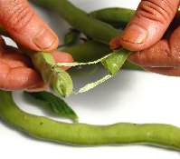

There are two kind

I pure paste , with this you do not nee to do any thing , just thin it with water, or with any liquis you want to use it with

2 with the see. Boil with some water and then stran

Pomegranate is different . there are two kind

Molasses has sugar , but every company make is different in sugar level. Some taste sweet and some still sour

Concentrate usually very sour

If it is sweet to you just add some lemon, and if too sour just do not add as much or boil some sugur in a water and add to it